**For loop**

For loop is an “Entry control loop” that’s means the control arrow enter inside for block (loop) to execute specific statements.

Browser executes the statement(s) inside for block (loop), until the given conditional expression evaluates to false.

**Syntax:**

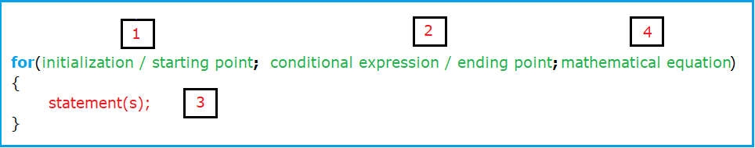

**How for loop keyword works?**

From the previous syntax we can see that for loop keyword consist of 4 parts:

Part 1: Initialization / starting point

Part 2: Conditional expression / ending point

Part 3: Statements also called “for block”

Part 4: Mathematical equation

**Note:** in case of undetermined the ending point infinity loops results.

We will use imaginary arrow to show us the path of execution the code:

The path of this arrow is shown in this picture:

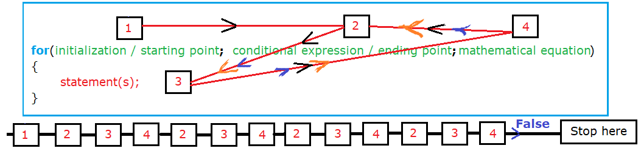

The arrow moves from 1 to 2 to 3 to 4 then to 2 to 3 to 4 to 2……

Because the condition expression is true the arrow will follow this path until the expression condition will be false then **exit** for keyword and go to execute the next down statements.

**Note**:

1. Arrow passes to number1 only one time (when **entering** the for keyword)
2. Loop path is expressed on numbers 2, 3, and 4.

**Example1:** on forward for loop from 1900 to 2000

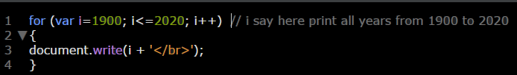

Illustration:

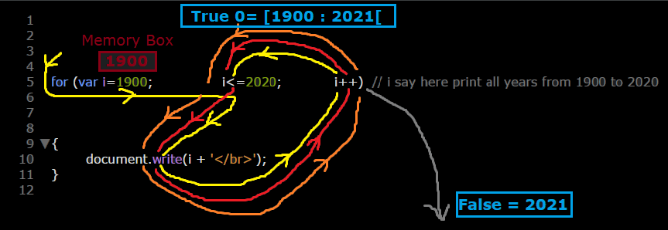

**Not**e: you can make sure from debugging this code in the source tool.

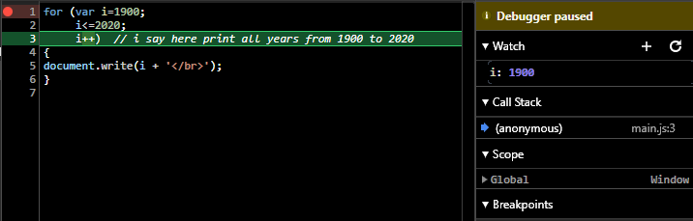

**Example2:** on reverse for loop. From 2000 to 1900

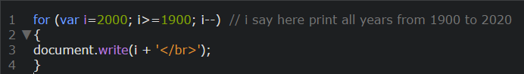

**Example3:**

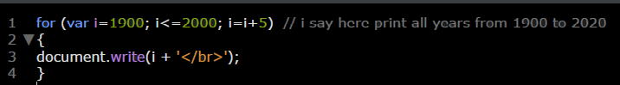

**Example4:** for loop with arrays

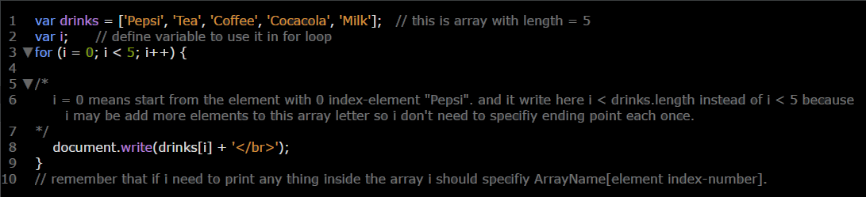

**Example 5:**

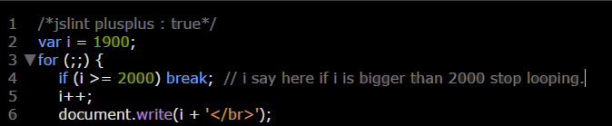

**Example 6:** Creating birth day inputs. “It’s better to use create element instead of document.write”

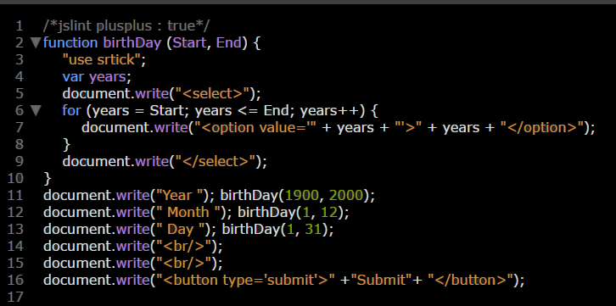

**Example 7:** on making a program used to find the factorial of a given number

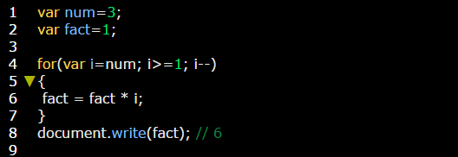

**Remember that:** Factorial number (n!) is all numbers between (n) to (1) multiplying with each other.

**Ex:**

1! = 1

2! = 2 x 1 = 2

3! = 3 x 2 x 1= 6

4! = 4 x 3 x 2 x 1 = 24

5! = 5 x 4 x 3 x 2 x 1 = 120

n! = n x (n-1) x (n-2) x ….. x 1

Illustration of previous example:

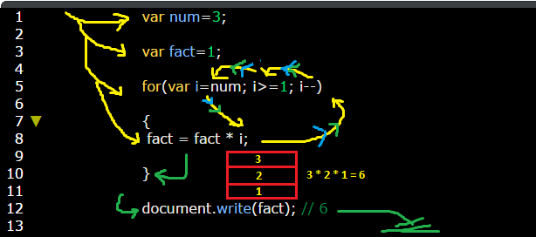

Because presence of output statement outside for loop body the values 3, 2, 1 will not printed separately, but it will storied in fact variable until the loop ended then the cursor will exist out and go to execute output statement and print fact variable

Fact = 3 * 2 * 1 = 6

**You can make sure from running this code in source tool.**

Note the yellow square which shows the storing value of fact.

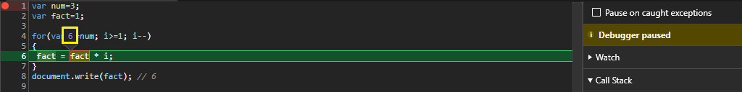

**Example:** Note the difference between this example and the previous one**:**

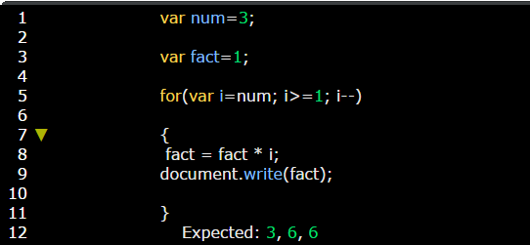

Expected: 3, 6, 6 will be printed separately as stored value in fact was printed directly after it stored so and then this value deleted to add another value. So here there is no chance to store all three values in the same variable "fact". So factorial number process isn't possible in this case'

**Example: on infinity loop.**

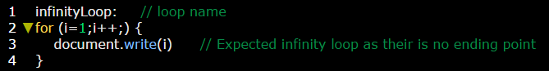

**Example:** on using inline variable (declaration and initialization of this variable were **both inside** parentheses of for statement).

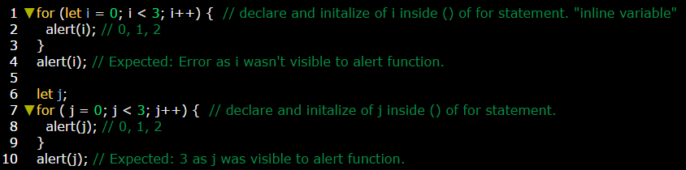

**Example:** on skipping loop parts.

**Example:** on using break to stop the iteration process.

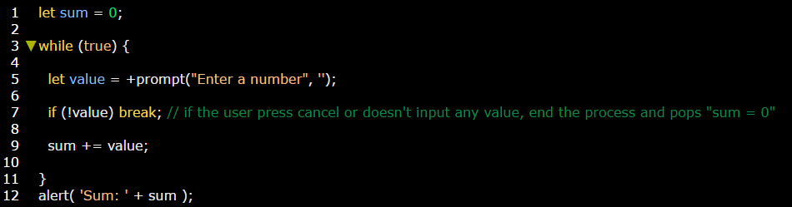

**Example:** on using continue keyword to cancel specific iteration.